Corporate Bankruptcy Prediction A Data Driven Early Warning System for Credit Risk Management

Introduction

Financial entities must evaluate the economic situation of the companies that are requesting credit in order to detect what credits need special attention. There are companies that despite having apparently good economic performance, could present economic issues that are not easy to detect. We can have a better understanding of the situation when we analyse multiple factors, and correlations.

It’s important to detect those indicators, as soon as possible, in order to make the most efficient decisions for the Financial Institutions. We have to find a balance between the detection of potential bankruptcies and minimising false alarms.

The project will also compare different Machine Learning models to see which one works better and which one is easier to understand.

PROBLEMS AND OBJECTIVE

Banks or Credit institutions need to look at different financial figures to understand the situation better.
If the bank does not find these problems at an early stage, it may lose money.
But that’s not the only problem. If the system says that a healthy company is at risk, the bank may spend time checking it.

The bank may also decide not to give money to a good company and lose a business opportunity.
As I previously said, the system needs to find a balance between two things: finding companies that may go bankrupt and avoiding false warnings about healthy companies.

The system will help credit risk analysts, portfolio managers, etc. They can use the information to decide which companies need more attention.
This project will study if financial data can help predict which companies may go bankrupt in the next year.

Bankruptcy means that a company has serious financial problems. But bankruptcy is not exactly the same as not paying back a bank loan.

The main question of this project is:

Can we use past financial data to predict if a company may go bankrupt next year and help banks make better decisions?

Objective
The goal of this project is to determine if we can use the financial data to find companies that may go bankrupt. This helps banks understand risk and improve decisions.

We will start looking at the data to see what financial problems the companies had before going bankrupt. The data will need some cleaning and we will probably create new financial numbers (like ratios) to help us understand it better.
After that, we will use two Machine Learning models, Logistic Regression and Random Forest. We will compare the results with a simple model to see which one works better.

We also need to test these models with data from different years. This will help us to understand how good their predictions are, especially because most companies do not go bankrupt.
We will look at the mistakes too, as predicting that a healthy company will go bankrupt can also be a problem.

At the end, we want to understand if these models can really help banks. We will explain the results, the problems with the models, and why people should still check the information before making decisions.

The idea is that past financial data can help predict future bankruptcies, and that Machine Learning may work better than a simple method. But we do not know this yet, so the project will help us find out how effective it is.

Scope

For this project I will use financial data from American companies listed on the NYSE and NASDAQ, from 1999 to 2018. I want to see if this information can help predict when a company may go bankrupt in the next year.

The project is only about companies, not personal loans or personal credit risk. I will not use private information from banks, and the system will not decide if a company should get a loan or not. It is also not a real system that a bank can use now.

One possible problem is that the data is old and only from the US. So maybe the results will be different for companies in Ireland today. Also, not all companies work in the same way and sometimes financial information is missing.

Methodology

For this project I will follow the data science life cycle that we studied in class. Discovery, data preparation, model planning, model building, communicate results and operationalize. It is a good way to organise the project and connect the data with the problem I want to study.

I will start with Discovery, where I need to understand the problem, what I want to find and how the results can help banks. I will also read some studies about bankruptcy prediction to see what other people have done before, and what problems they found.

Then I will prepare the dataset. I will check for any missing information, duplicated data or something incorrect. Another important thing is to see how many companies went bankrupt and how many did not. I may also calculate some financial ratios to help understand the situation of each company. I will be careful to only use information that was available before they went bankrupt.

For the models, I plan to use logistic regression and random forest. The logistic regression is simpler and easier to explain, while the random forest can find more complex patterns. I will also use a very basic model to compare the results and see if machine learning is really helping.

I will split the data by years. The data from 1999 to 2011 will be for training, 2012 to 2014 for validation, and 2015 to 2018 for testing. I want to test the models with information from later years, like in a real situation. Some companies also appear in different years, and I will consider this.

To check how well the models work, I will use different metrics like Precision, Recall, Confusion Matrix, etc. Accuracy alone is not enough because most companies in the dataset do not go bankrupt.

For example if the model does not find a company that will go bankrupt, this can be a problem for a bank. But if it gives too many false warnings, analysts may lose time checking healthy companies. I want to see if the models can find a good balance between these two problems.
I will also look at which financial variables are more important for the predictions. This can help us understand the results, but it does not mean that these variables are the direct cause of bankruptcy.

At the end, I will show the results using tables and graphs, and explain what they mean for credit risk. If I have enough time, I would like to create a small dashboard to show how an analyst could use the information. This will only be a prototype, not a real banking system.

I will use Jupyter Notebook. I will also include a simple diagram to show the different steps of the project, from getting the data to the final results and the review by an analyst.

Data Sources

I found the American Companies Bankruptcy Dataset on GitHub and decided to use it for my project. It has information about 8,262 American companies between 1999 and 2018, with 78,682 records in total.

What I like about this dataset is that it has 18 financial indicators and also tells us if a company went bankrupt in the next year. It includes bankruptcies under Chapter 7 and Chapter 11 in the US. The authors say there is no missing data, but I still want to check everything before using it (Lombardo et al., 2022).

The dataset is public and the companies are anonymised. It uses a CC BY 4.0 licence, so I need to give credit to the authors. The original data with company names also has some restrictions. I will check this before sharing anything and make sure the sources are included in my work.

Expected Deliverables

By the end of the second semester I hope to have a project that shows if financial data can really help us find companies that may go bankrupt.

I will spend some time understanding the dataset first. I think this is important because I don't want to just put the data into a model without knowing what the numbers mean. I will clean the information, look for patterns and prepare everything using Python.

After this, I plan to work with Logistic Regression and Random Forest. I want to compare both models and also use a very simple one as a reference. It will be interesting to see if the more complex model actually gives better results.

I would like to present my results with graphs and tables that are easy to understand. I also want to create a small dashboard. I think it could make the project more interesting and show how someone working in credit risk might use this information.

My final report will explain the work I did, what I found and the limitations of the project.
I know that a model like this will not be perfect. For me the most interesting part is finding out if it can be useful in a real business situation even if the results are not as good as I expect.

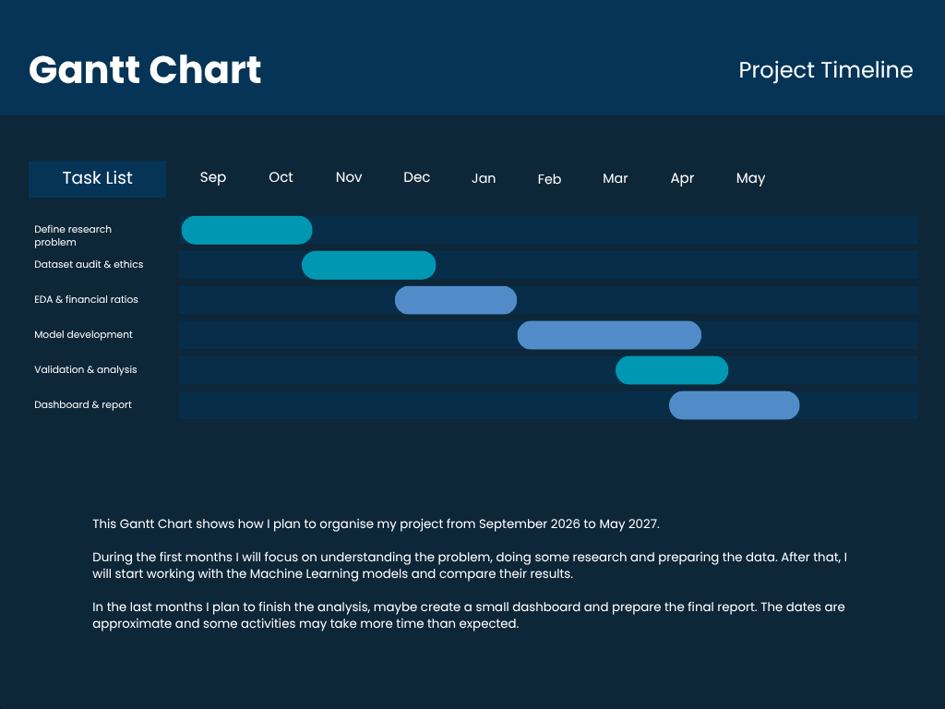

Ethical and Legal Considerations

We talked about GDPR in class, and I understand that we need to be careful with the information used. I will only use the data I need and try to keep everything safe. If I ever need to use personal information, I would have to check the GDPR rules first. I also need to give credit to the people who created the dataset and respect the license.

In class we studied the EU AI Act. I think it is important to look at it, even if my project is only about predicting company bankruptcies and not deciding if a person can get a loan. My idea is that the system should help analysts, not make decisions for them. They should be able to understand the results and check them before taking any action.

Something that worries me a little is that the model could make mistakes. For example, it may say that a company is at risk when actually the company is doing well. This could be a problem if a bank makes decisions only based on the model. The information is also quite old and maybe the results are not the same for all types of companies.

I will include the sources I use and also mention any help I received from AI tools, as required by CCT. I want to be clear about what I did myself and what tools I used during the project.

References

CCT College Dublin - Data Analytics Life Cycle, Research, Citing and Referencing. Strategic Thinking class materials.

Lombardo, G., Pellegrino, M., Adosoglou, G., Cagnoni, S., Pardalos, P.M. and Poggi, A. (2022) 'Machine Learning for Bankruptcy Prediction in the American Stock Market: Dataset and Benchmarks',
14(8), p. 244. Available at: https://doi.org/10.3390/fi14080244

sowide (n.d.) *bankruptcy_dataset*. GitHub. Available at: https://github.com/sowide/bankruptcy_dataset

